AI for Mental Health
Toward More Empathetic and Context-Aware Systems
Research Proposal
Student: Myint Myat Kyaw ID: 6610207
Course: CSC485 Instructor: Dr.Chutima

Research Topic
AI for Mental Health: Toward More Empathetic and Context-Aware Systems

Chapter 1

1.1 Introduction
Artificial Intelligence (AI) has become increasingly visible in mental-health–adjacent tasks, such as screening for depressive language, monitoring distress signals, and providing basic conversational support. Despite these advances, a persistent gap remains between technical capability and human-centered care. Models can classify emotion yet fail to respond with empathy or cultural sensitivity; they may generalize poorly for underrepresented groups, or produce supportive text that feels mechanical or inappropriate. These shortcomings undermine user trust and risk emotional harm. Accordingly, this project addresses the challenge of designing AI systems that are both context-aware and empathetic, while being transparent about limitations and attentive to fairness.

1.2 Research Objectives
The objectives of this research are as follows:
1) To synthesize design requirements for empathetic, context-aware responses from recent literature in AI for mental health.
2) To propose and implement a small, text-based prototype that integrates tone/emotion detection with empathy-guided response generation.
3) To evaluate empathy, appropriateness, and fairness using human ratings and standard metrics, disaggregated across subgroups (e.g., dialect/language variants).
4) To document ethical guardrails, interpretability cues, and deployment guidelines suitable for student-scale research.

1.3 Research Question
How can AI systems be developed to be more sympathetic and emotionally intelligent in mental health care?

1.4 Research Framework
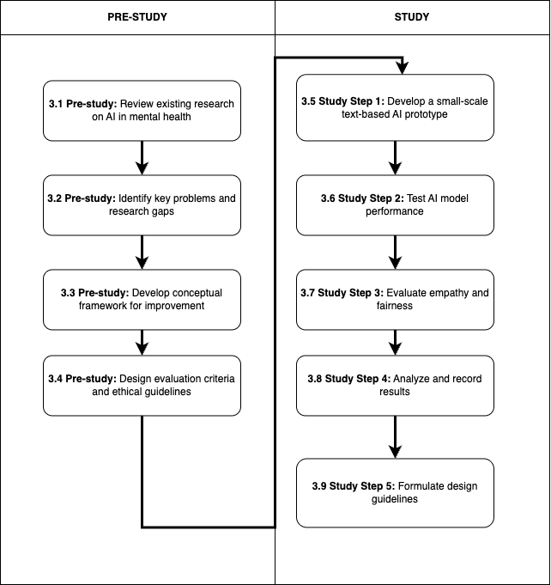
Fig. 1. The Steps of the pre-study and study

Chapter 2

Related Literature Review
This section reviews relevant topics and research essential to the study: empathy and emotional intelligence in dialogue systems; NLP techniques for emotion, tone, and context; and fairness/ethics considerations for mental-health–adjacent AI.

2.1 Topic/Theory 1: Empathy and Emotional Intelligence in Dialogue Systems
Empathy in computational systems involves identifying user emotions and responding in ways that acknowledge, validate, and support the user’s feelings. In mental-health–adjacent contexts, appropriate supportive behaviors include reflective listening, non-judgmental language, and gentle signposting to professional help when necessary. The notion of moving from ‘Artificial Intelligence’ toward ‘Artificial Wisdom’ emphasizes embedding values (empathy, fairness, humility) in design decisions and evaluation.

2.1.1 Subtopic 1: Counseling Micro‑skills in AI Responses
Micro‑skills such as validation ("what you’re feeling makes sense"), reflection (paraphrasing feelings), and empowerment (encouraging healthy actions) can be mapped to response templates or prompting strategies that help stabilize tone and reduce harmful phrasing. These skills offer practical, auditable rules for student‑scale prototypes.
1) Subtopic 2: Interpretability for Trust
Even simple interpretability (e.g., highlighting influential phrases for tone classification and documenting response rules) can improve user trust and help researchers debug unfair or unsafe outputs.

2.2 Topic/Theory 2: NLP for Emotion, Tone, and Context
Modern NLP models (e.g., transformer-based classifiers) can detect emotions and intent with strong performance on benchmark datasets. However, generalization to real-world, culturally diverse language (including slang, sarcasm, and code‑mixing) remains challenging. Robustness can be improved through data augmentation, multilingual variants, and explicit evaluation across subgroups.

2.1.2 Subtopic 1: Fairness and Bias in Language Models
Empirical studies show performance gaps for underrepresented communities when models are trained/evaluated on narrow datasets. Fairness protocols for this project therefore require disaggregated metrics and qualitative review of outputs for culturally insensitive wording.
1) Subtopic 2: Safety in Mental‑Health–Adjacent AI
Systems must avoid pretending to diagnose or treat; crisis cues should trigger supportive language that encourages contacting local emergency services or trusted professionals.

2.3 Related Researches
Table 1 summarizes six sources and their relevance to the research question.
Paper | Scope of work | Objective of the work | Method Used | Finding | Relation to our research question
Reuters (2024): AI fails to detect depression in Black Americans | News report on peer‑reviewed study; language‑based depression screening | Assess bias across racial groups | Off‑the‑shelf models on social‑media language vs. validated questionnaire | Much lower predictive validity for Black participants | Motivates fairness checks and subgroup evaluation
Lee et al. (2021) – PMC: AI in Mental Healthcare; Artificial Wisdom | Review of clinical AI applications, barriers, facilitators | Map opportunities and risks; argue values‑aware design | Literature synthesis | Gap between research promise and clinical use; need empathy/fairness | Inspires empathy‑centered requirements and ethics framing
BMC Psychiatry (2025): Systematic review of AI in mental health | Survey of applications across diagnosis, monitoring, prediction | Summarize performance and gaps | Systematic review | Heterogeneous methods; limited external validation | Supports need for standardized evaluation and diverse data
Psychological Medicine (Cambridge): Review of diagnosis/monitoring/intervention | Broad review of AI in MH care | Identify technical and ethical limitations | Literature synthesis | Privacy, interpretability, deployment barriers | Guides interpretability and safety requirements
arXiv (2024): Emotional modeling for dialogue systems | Techniques for affect representation and generation | Improve affect‑aware responses | Method proposals; experiments | Modeling affect can enhance response quality | Grounds the empathy module of the prototype
arXiv (2025): Conversational empathy and fairness | Assessment and improvement of empathy with fairness tracking | Jointly optimize empathy and fairness | Benchmarks and analyses | Empathy metrics can be combined with subgroup audits | Directly informs evaluation plan
It was found across sources that models may underperform for certain communities and that emotionally neutral outputs can be perceived as unsupportive. Therefore, this study prioritizes empathy-by-design and fairness-aware evaluation.

Chapter 3: Research Methodology

3.1 Research Design
This study adopts a mixed-methods research design, combining system development, user-centered evaluation, and qualitative analysis. The objective is to build an empathetic mental-health support chatbot prototype that integrates emotion detection with empathy-guided response generation. Quantitative metrics and qualitative feedback from participants are used to evaluate performance.

3.2 System Requirements

3.2.1 Functional Requirements
- Detect user emotion and tone
- Generate empathetic responses
- Provide crisis-safe suggestions
- Highlight emotional cues
- Maintain conversation history
- Allow admin to update empathy templates
- Allow admin to configure safety rules

3.2.2 Non-Functional Requirements
- Respond within 1–3 seconds
- Maintain user privacy
- Use culturally appropriate language
- Simple and accessible web interface

3.3 Use Case Diagram
Figure X presents the use case diagram showing interactions between system actors (User and Admin) and the chatbot system. The User can send messages, receive empathetic responses, view emotional insights, receive safety suggestions, and review chat history. The Admin can manage empathy templates, configure safety rules, and monitor system logs.
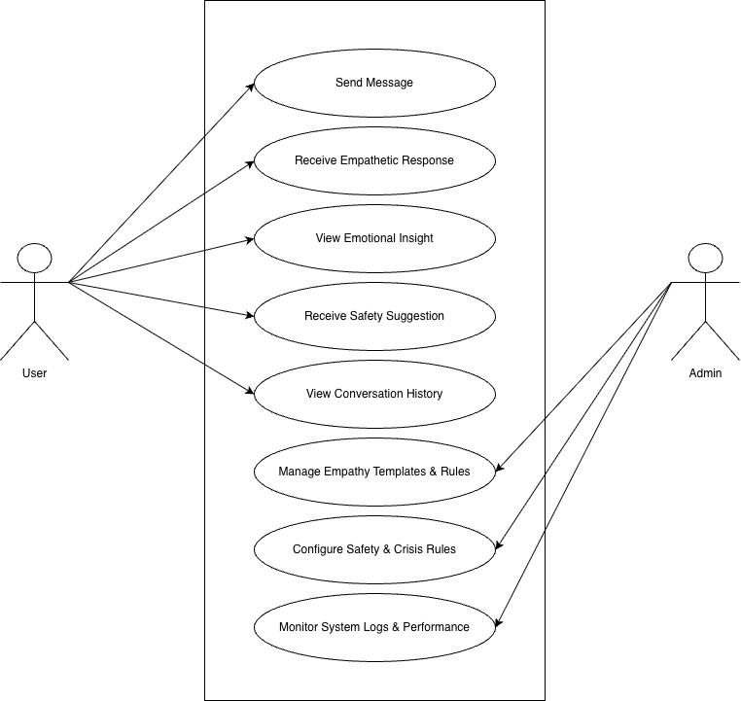
Figure 3.3 use case diagram

3.4 Use Case Descriptions
This section provides descriptions for the key use cases of the system.

Use Case: Send Message
Actor: User
Precondition: The user is on the chat interface.
Main Flow:
1. User types a message.
2. System receives input.
Postcondition: Message is processed by the system.

Use Case: Receive Empathetic Response
Actor: User
Main Flow:
1. System analyzes message.
2. Emotion classifier identifies tone.
3. Empathy engine applies micro-skills.
4. System generates empathetic output.
Postcondition: User receives chatbot response.

3.6 Prototype Development Process
1. Requirement gathering
2. Use case and architecture design
3. Dataset selection and preprocessing
4. Implementation of emotion classifier
5. Design of empathy templates and prompts
6. Integration with LLM response generator
7. UI development using a simple website interface
8. Testing and refinement
9. Evaluation with users

3.6.1 User Interface (UI) Screenshot
The following figure presents the prototype interface of the empathetic mental-health support chatbot.
The UI provides a simple chat box that allows users to type messages and view responses generated by the system.
Figure 3.6.1 Website UI Prototype
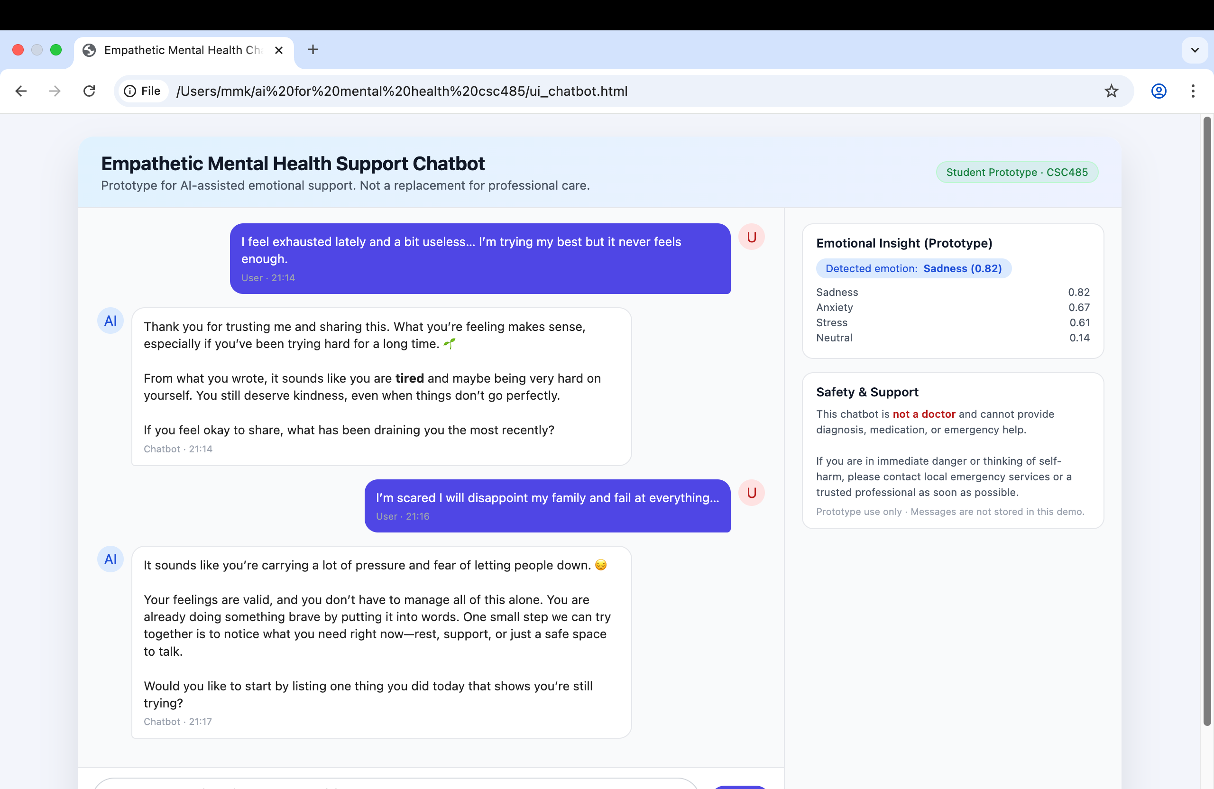

3.7 Dataset and Model Selection
The study uses a pre-trained emotion classifier based on datasets such as GoEmotions. Using pre-trained models ensures safe and stable performance suitable for student-scale research. LLM-based response generation includes carefully designed prompts emphasizing empathy, validation, and cultural appropriateness.

3.8 Evaluation Methods

3.8.1 Human Evaluation
Participants rate chatbot responses using a 1–5 Likert scale on empathy, clarity, appropriateness, safety, and cultural sensitivity.

3.8.2 Technical Evaluation
Emotion classifier performance is evaluated using accuracy and F1-score. Fairness analysis checks performance across different types of user messages.

3.8.3 Qualitative Feedback
Participants provide open-ended comments about response suitability and emotional alignment.

3.9 Ethical Considerations
The system avoids medical claims or diagnosis. Crisis-related cues trigger safety messages recommending professional help. User privacy is respected, and no personal data is stored. The model is designed to avoid biased or culturally insensitive outputs.

3.10 Limitations
Limitations of this study include small sample size, dependency on model accuracy, limited handling of complex slang or mixed-language text, and the constraint that the system cannot replace professional mental health services.

CHAPTER 4
RESULTS AND DISCUSSION

4.1 Overview of Evaluation
This chapter presents the results and discussion derived from the development and evaluation of the empathetic mental health chatbot prototype. The evaluation emphasizes qualitative system behavior and user perception rather than predictive accuracy or clinical performance. This approach aligns with the project objective of developing a supportive, non-diagnostic conversational agent.

4.2 Qualitative Interaction Analysis
Figure 4.1 and Figure 4.2 present qualitative observations derived from representative user–chatbot interactions. These examples illustrate how the chatbot acknowledges user emotions, responds with empathetic language, and avoids judgmental or clinical phrasing.
Figure 4.1: Sample chatbot interaction demonstrating empathetic acknowledgment and supportive tone.
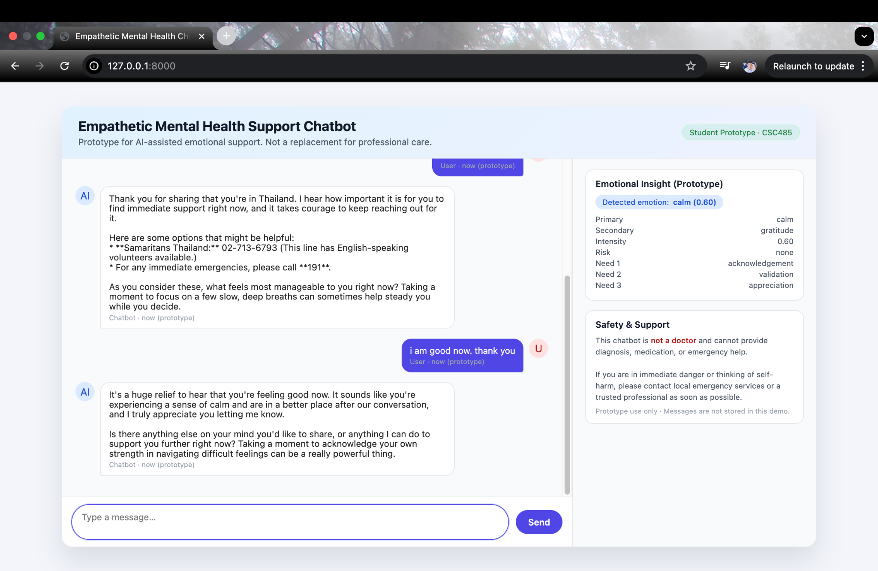
Figure 4.2: System processing flow for emotion detection, safety assessment, and response generation.

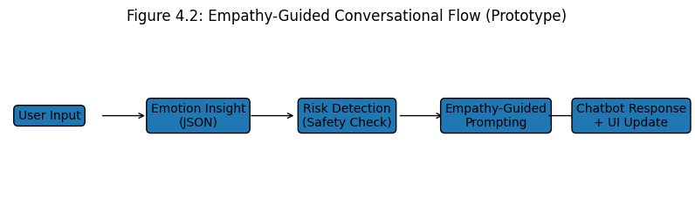4.3 User Feedback and Survey Results
User feedback was collected through a small-scale survey involving five participants. Participants interacted freely with the chatbot and evaluated their experience using a Likert-scale questionnaire.
Figure 4.3: Overall perception of emotional support and usefulness.
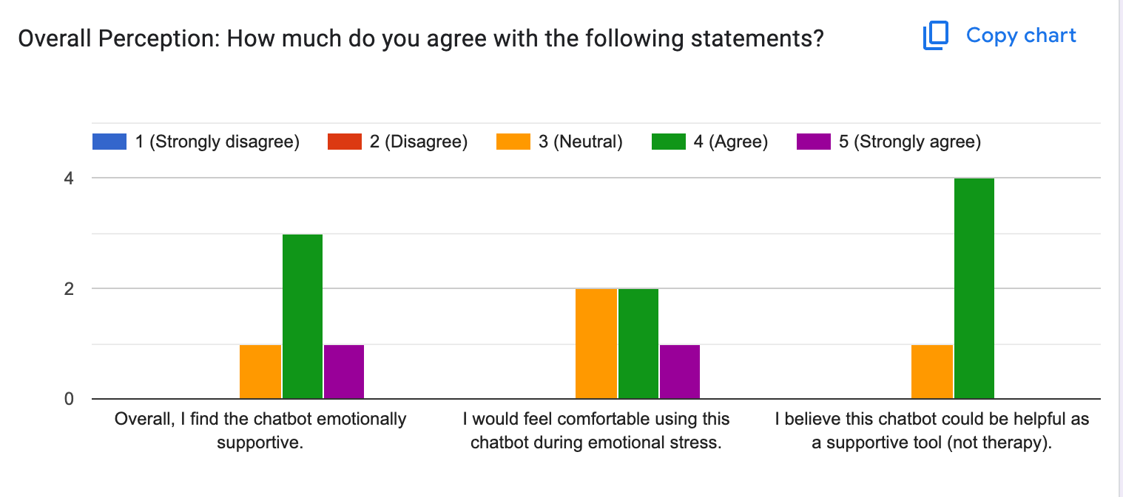
Figure 4.4: Safety and responsibility perception of the chatbot.
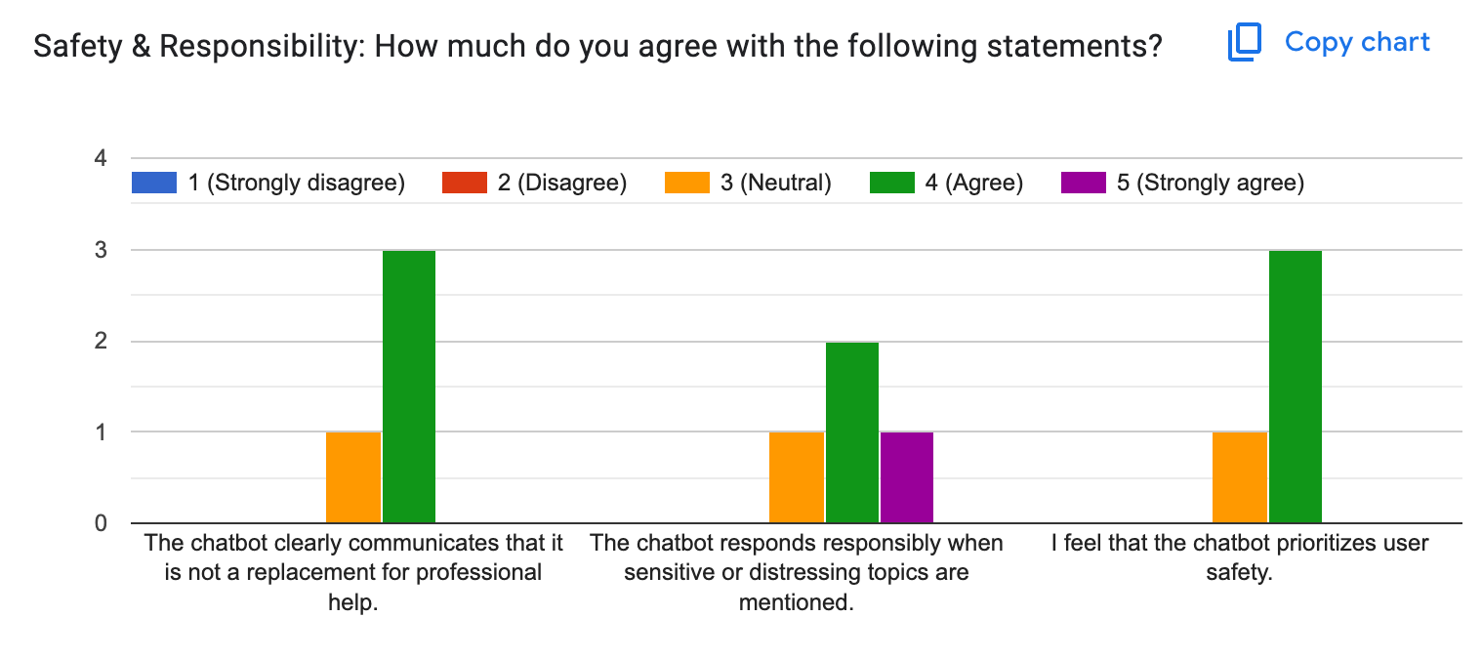
Figure 4.5: Emotional insight transparency and empathy perception.
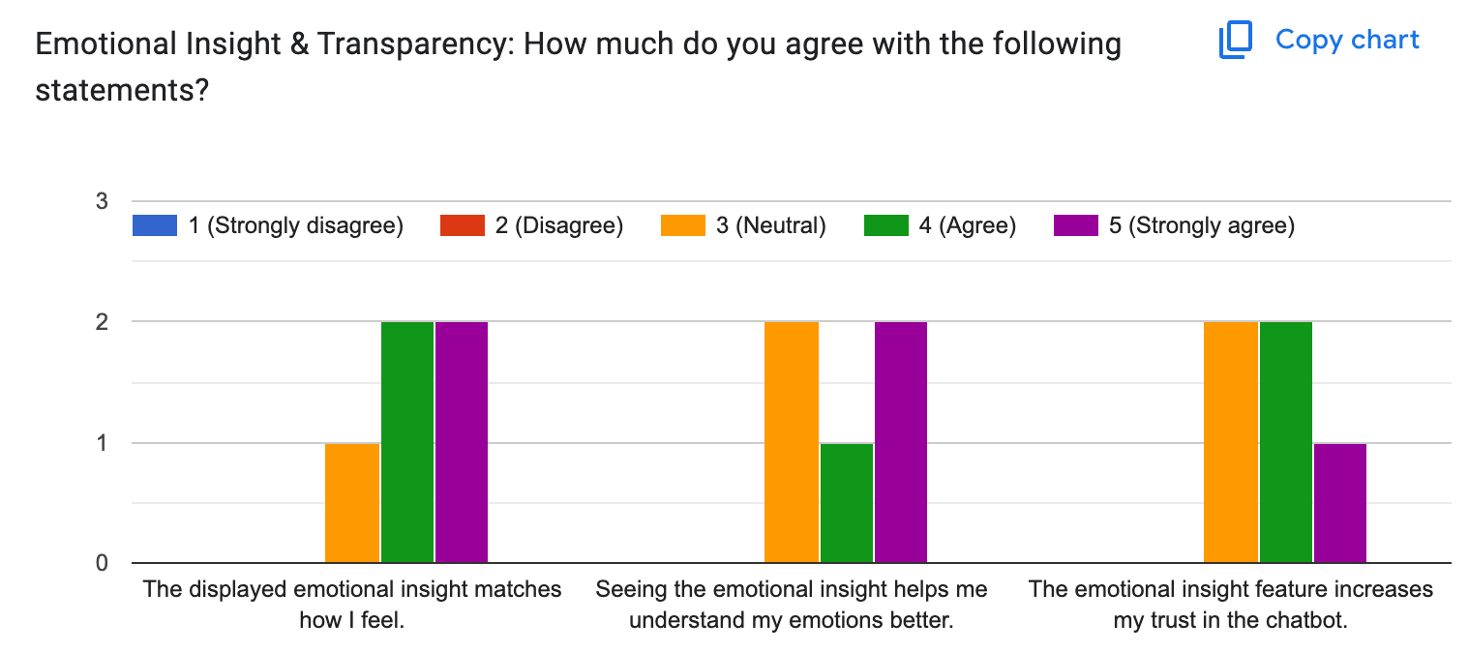

4.4 Discussion of Results
Survey results indicate that most participants perceived the chatbot as emotionally supportive and appropriate for non-clinical emotional assistance. Users reported that the chatbot clearly acknowledged emotions, maintained a warm tone, and respected ethical boundaries.
The emotional insight feature increased user trust by making the system’s interpretation transparent. Additionally, safety mechanisms—such as disclaimers and crisis guidance—were perceived as responsible and reassuring.
These findings demonstrate that empathetic conversational behavior can be effectively achieved through prompt engineering, structured response logic, and interface design without requiring custom model training.

4.5 Limitations
Despite positive feedback, the evaluation has several limitations. The participant sample size was small, and results may not generalize to broader populations. Furthermore, emotional interpretation relies on a pre-trained language model, which may occasionally misinterpret user intent.

4.6 Chapter Summary
This chapter presented qualitative and user-centered evaluation results for the empathetic chatbot prototype. Overall, the system successfully demonstrated emotionally aware and ethically responsible conversational behavior within its intended scope.

CHAPTER 5
CONCLUSION

5.1 Conclusion
This study presented the design and implementation of an empathetic mental health chatbot prototype that integrates emotion awareness, empathetic response generation, and ethical safety constraints. The system demonstrates that pre-trained language models can be adapted to support emotionally sensitive interactions through careful prompt design and interface transparency.

5.2 Contributions of the Study
The primary contributions of this study include the development of an empathy-guided conversational architecture, the implementation of transparent emotional insight visualization, and the integration of safety-aware response mechanisms. The project also provides a practical example of responsible AI usage in mental health–adjacent contexts.

5.3 Limitations
This study is limited by its reliance on qualitative observation rather than large-scale user evaluation. The chatbot is not clinically validated and does not replace professional mental health services. Additionally, system performance is dependent on the underlying pre-trained language model.

5.4 Future Work
Future work may include formal user studies, multilingual emotion handling, personalization through emotional memory, and hybrid approaches combining symbolic emotion models with language-based generation.

References
Reuters (2024). AI fails to detect depression signs by Black Americans. https://www.reuters.com/business/healthcare-pharmaceuticals/ai-fails-detect-depression-signs-social-media-posts-by-black-americans-study-2024-03-28/
Lee et al. (2021). Artificial Intelligence for Mental Healthcare: Clinical Applications, Barriers, Facilitators, and Artificial Wisdom. https://pmc.ncbi.nlm.nih.gov/articles/PMC8349367
BMC Psychiatry (2025). The application of artificial intelligence in the field of mental health: a systematic review. https://bmcpsychiatry.biomedcentral.com/articles/10.1186/s12888-025-06483-2
Psychological Medicine Review (Cambridge). AI in mental health care: a systematic review of diagnosis, monitoring and intervention applications. https://www.cambridge.org/core/journals/psychological-medicine/article/artificial-intelligence-in-mental-health-care-a-systematic-review-of-diagnosis-monitoring-and-intervention-applications/04DBD2D05976C9B1873B475018695418
arXiv (2024). https://arxiv.org/abs/2406.11852
arXiv (2025). https://arxiv.org/abs/2502.00451

